MOUNT LITERA ZEE SCHOOL , HARIDWAR
Class SR.KG SYLLABUS OF EVALUATION-2 (2017-18)

EVS-
WRITTEN-

- Flowers
- Fruits
- Vegetables
- Parts of plants
- Uses of plants
- Care of plants
- Animals
- Insects

ORAL –

- Animals & their young ones
- Sounds of animals
- Homes of animals
- Uses of animals
- Animals & their food

NOTE – ALL THE SYLLABUS WILL BE INCULDED FROM BOOK – 5 AND WORK DONE IN EVS NOTEBOOK.
MATH (WRITTEN)

- Counting - 1 to 100
- Before/After/Between – 1 to 100
- Smaller/Bigger number – 1 to 100
- Missing number – 1 to 100
- Number name – 1 to 50
- Skip counting
- Addition sums

MATH (ORAL)
- Months name (spellings)
- Related question –for example --How many months make a year?
What comes after May?
What comes before March?
- Days name (spelling)
- Related questions –for example --How many days make a week?
What comes after Tuesday?
What comes before Saturday?
ENGLISH (Written ) :
- Name the picture ( pg no. 12 ,17 , 25 , 28 , 31 , 34 in Book – 6 )
- Story Comprehension ( Done in notebook )
- Dictation
tree , grass , brave , pray , frog , chop , whale
ship , slide , phone , snail , flag , glass , plate
black , clock , oil , train , bench , photo .
- Singular / Plural
( Pen - pens , flower - flowers , train – trains , star - stars ,
Book – books , table – tables , apple – apples , cap – caps , bag – bags , shoe – shoes )
- Action words ( See the picture and write its name )
( play , drink , jump , run , write , read , cook , pray , cry , laugh )
- Opposites
Eg. Big – small , empty – full , many – few , long - short , up – down , day – night , near – far , first – last , open – close , one - many
- Short vowel / Long vowel
Eg . tub – tube , cut – cute , not – note , rod – rode ,
pin – pine , bit – bite , rat – rate , tap – tape
- This / That / These / Those
( pg no. 8 to 18 in Book – 7 , pg no. 2 , 3 in Book – 8 )
- One / Many ( pg no. 5, 6 , 7 in Book – 7 , pg no. 4 , 5 in Book – 8 )
English ( Oral ) :
- Reading of Blends and sentences ( pg no. 14 & 15 in Book – 8 )
- Rhymes : Pat a cake , Five friendly freedom fighters ( with introduction ) (Book 3)
- Story : 1. Elly the elephant
2. The Little Red Riding Hood ( Any one story with introduction and moral )(Check Portal)
Hindi Syllabus

1- rhu, pkj v{kj okys 'kCnA
2- vk (k ), b ( f ), bZ ( h) dh ek=kA
3- fjDr LFkku HkjksA
4- fp= igpku dj 'kCn fy[kksA
5- ,d rqd okys 'kCnA
6- fp= o.kZu & xk;A
7- Jqrys[kA
8- dgkuh & I;klk dkSvkA (ekSf[kd)
9- dfork & 1- eNyh us [kk fy;k vpkjA
2- ,d ,d ;fn isM+ yxkvksaA
3- isM+ yxkvksa isM+ yxkvksaA
4- nhokyh vkbZ nhokyh vkbZA
(any two with introduction)

10- nksgs & ( कोई एक )
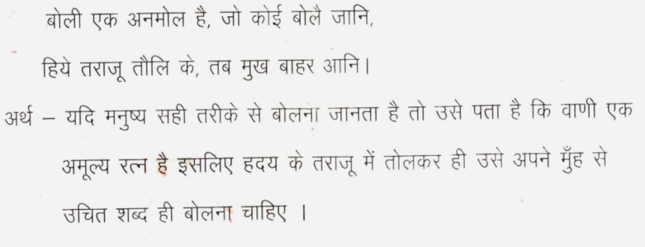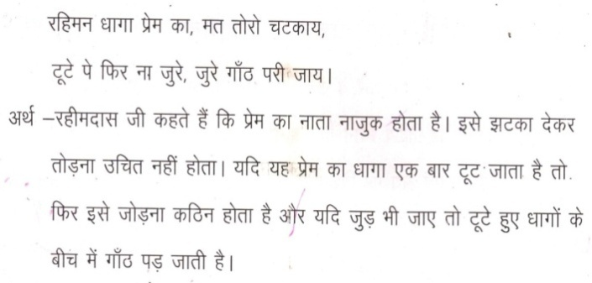
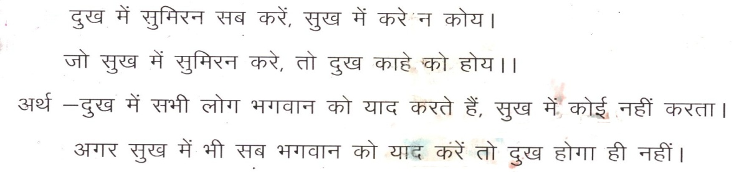

Revised Datesheet (December) CLASS:- Sr.KG
DATE | DAY | SUBJECTS
4-12-17 | MONDAY | ENGLISH (Written)
5-12-17 | TUESDAY | ENGLISH (Orals)
6-12-17 | WEDNESDAY | MATH (Written)
7-12-17 | THURSDAY | MATH (Orals)
8-12-17 | FRIDAY | HINDI (Written)
11-12-17 | MONDAY | HINDI (Orals)
12-12-17 | TUESDAY | E.V.S. (Written)
13-12-17 | WEDNESDAY | E.V.S./G.K. (Orals)

